SQL PROJECT REPORT
AIRLINE RESERVATION SYSTEM

Submitted By: SIDDHESH THAKARE
Guided By: Mr. Sameer Warsolkar Sir
Course: Data Analyst
Academic Year: 2026-27

1. Abstract
The Airline Reservation System is a database management project designed to store and manage information related to airline operations and passenger reservations. The system maintains data about airlines, airports, aircraft, flights, passengers, bookings, seats, and payments in separate but interconnected relational tables.
The database uses primary keys and foreign keys to maintain relationships and data integrity between different entities. For example, flights are associated with airlines, aircraft, source airports, and destination airports, while bookings connect passengers with flights. Seat allocation and payment information are separately maintained and linked to bookings.
The project also demonstrates SQL operations such as creating databases and tables, inserting records, filtering records using WHERE, sorting using ORDER BY, and retrieving related information using JOIN. This makes the project useful for understanding the practical implementation of a relational database system.

2. Introduction
An airline reservation system requires the management of a large amount of interconnected information. This includes airline details, airport information, aircraft details, flight schedules, passenger information, reservations, seat assignments, and payment transactions.
The purpose of this project is to implement an Airline Reservation Database using SQL. The database is named airline_reservation, and it contains separate tables for different components of the reservation process.
The system begins with basic airline and airport information. Each aircraft is associated with an airline, and each flight contains information about its airline, aircraft, source airport, destination airport, departure time, arrival time, fare, and status.
Passenger details are stored independently, while the booking table connects passengers to particular flights. Each booking contains the booking date, travel class, booking status, and total amount. Seat and payment details are then linked to individual bookings.
The project therefore demonstrates how a real-world airline reservation process can be represented using a relational database model.

3. Objectives
The main objectives of the Airline Reservation System are:
- To create a structured airline database for storing reservation-related information.
- To maintain airline information, including airline name, country, phone number, and email.
- To store airport information, including airport code, airport name, city, state, and country.
- To maintain aircraft information, including aircraft model, number of seats, manufacturing year, and associated airline.
- To manage flight information, including flight number, airline, aircraft, source, destination, departure time, arrival time, fare, and flight status.
- To maintain passenger records, including name, gender, age, contact information, city, and passport number.
- To manage flight bookings by connecting passengers with flights.
- To manage seat allocation for individual bookings.
- To maintain payment information, including payment method, payment status, payment date, and amount.
- To demonstrate SQL querying techniques, including filtering, sorting, and joining multiple tables.
- To maintain data integrity through primary keys, foreign keys, unique constraints, and NOT NULL constraints.

4. Tools and Technologies
Based on the SQL file, the following tools/technologies are involved:
Tool / Technology | Purpose
SQL | Database creation, table creation, data insertion, and data retrieval
MySQL | The SQL syntax strongly indicates a MySQL-style relational database environment
Relational Database Management System (RDBMS) | Stores data in related tables
Primary Keys | Uniquely identify records
Foreign Keys | Establish relationships between tables
JOIN | Retrieve related information from multiple tables
WHERE | Filter records according to conditions
ORDER BY | Sort query results
DECIMAL | Store monetary values such as fares and payments
DATETIME | Store flight departure and arrival date/time
YEAR | Store aircraft manufacturing year
The file specifically creates the airline_reservation database and uses SQL CREATE TABLE, INSERT INTO, SELECT, WHERE, ORDER BY, and JOIN statements.

Database Design
The database follows a relational database design, where different real-world entities are represented as separate tables and relationships are established using foreign keys.

4.1 Table Description
Main Tables
Table | Main Purpose | Primary Key
airline | Stores airline details | AIRLINE_ID
airport | Stores airport details | AIRPORT_ID
aircraft | Stores aircraft information | AIRCRAFT_ID
flight | Stores flight schedules and fares | FLIGHT_ID
passenger | Stores passenger information | PASSENGER_ID
booking | Stores reservation information | BOOKING_ID
seat | Stores seat allocation | SEAT_ID
payment | Stores payment information | PAYMENT_ID

4.2 Table Structure
4.2.1 Airline Table
DESC airline;
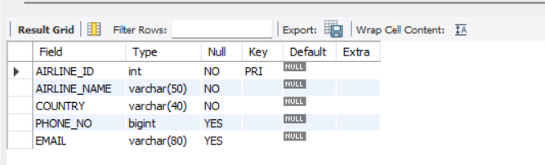

4.2.2 Airport Table
DESC airport;
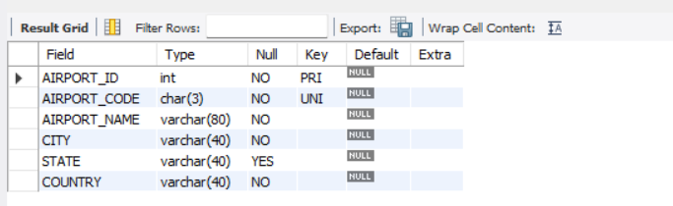

4.2.3 Aircraft Table
DESC aircraft;
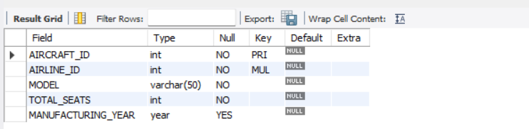

4.2.4 Flight Table
DESC flight;
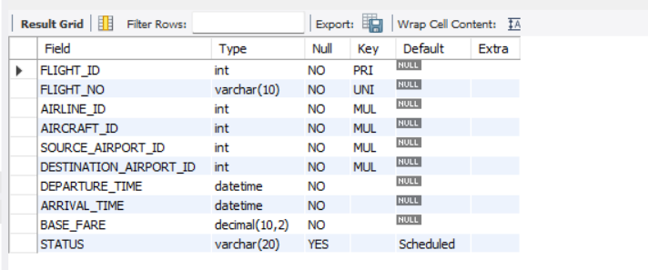

4.2.5 Passenger Table
DESC passenger;
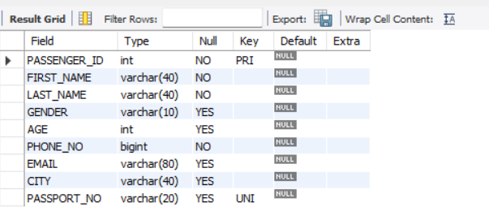

4.2.6 Booking Table
DESC booking;
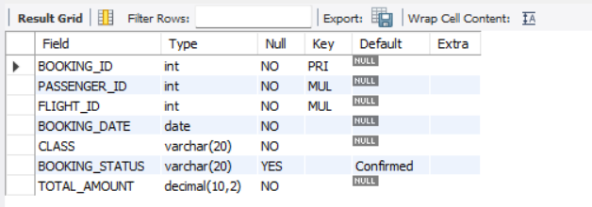

4.2.7 Seats Table
DESC table;
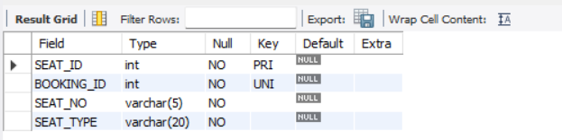

4.2.8 Payment Table
DESC payment;
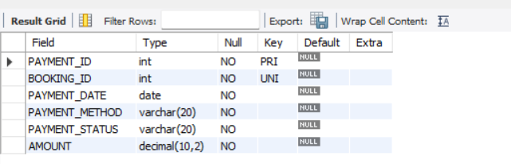

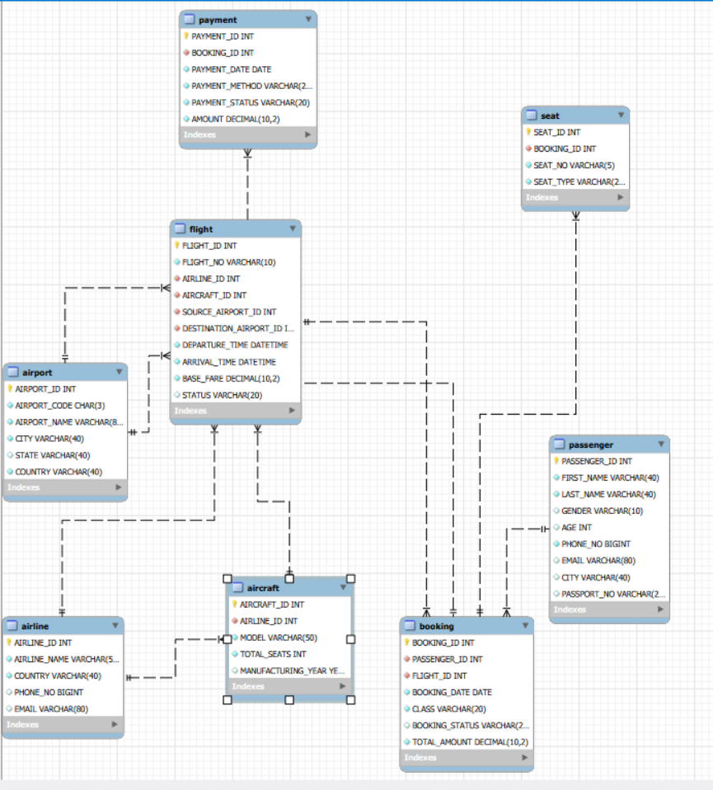
4.3 Relationship Diagram of Airline Reservation System

SQL Queries and Analysis
Database Creation:
CREATE DATABASE airline_reservation;
USE airline_reservation;

Table creation:
- Airline
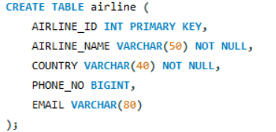

- Airport
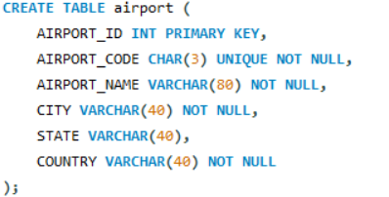

- Aircraft
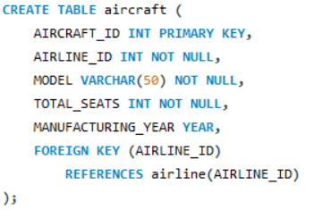
- Flight
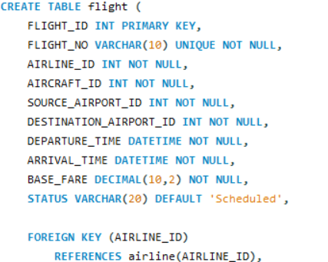
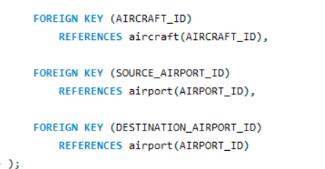

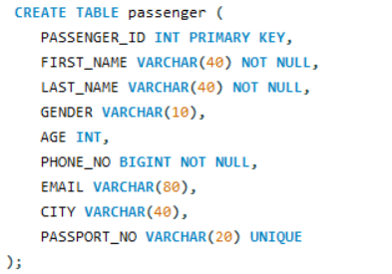
- Passenger

- Booking
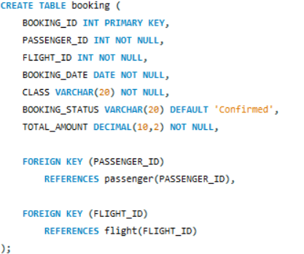

- Seats
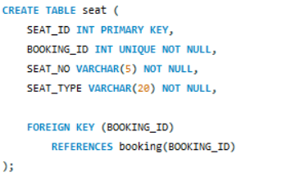

- Payment
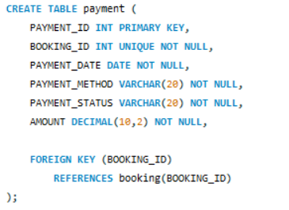

Data Insertion
- Insert Into Airline Table
INSERT INTO airline
(AIRLINE_ID, AIRLINE_NAME, COUNTRY, PHONE_NO, EMAIL)
VALUES
(1, 'Air India', 'India', 18002331401, 'support@airindia.com'),
(2, 'IndiGo', 'India', 18001803838, 'support@indigo.com'),
(3, 'Vistara', 'India', 9289228888, 'support@vistara.com'),
(4, 'Emirates', 'UAE', 80077777, 'support@emirates.com'),
(5, 'Singapore Airlines', 'Singapore', 6222118888, 'support@sia.com');

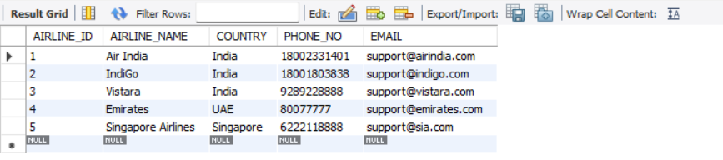
SELECT * from airline;

- Insert Into Airport Table
INSERT INTO airport
(AIRPORT_ID, AIRPORT_CODE, AIRPORT_NAME, CITY, STATE, COUNTRY)
VALUES
(101, 'BOM', 'Chhatrapati Shivaji Maharaj International Airport', 'Mumbai', 'Maharashtra', 'India'),
(102, 'DEL', 'Indira Gandhi International Airport', 'Delhi', 'Delhi', 'India'),
(103, 'BLR', 'Kempegowda International Airport', 'Bengaluru', 'Karnataka', 'India'),
(104, 'MAA', 'Chennai International Airport', 'Chennai', 'Tamil Nadu', 'India'),
(105, 'HYD', 'Rajiv Gandhi International Airport', 'Hyderabad', 'Telangana', 'India'),
(106, 'CCU', 'Netaji Subhas Chandra Bose International Airport', 'Kolkata', 'West Bengal', 'India'),
(107, 'PNQ', 'Pune International Airport', 'Pune', 'Maharashtra', 'India'),
(108, 'GOI', 'Goa International Airport', 'Goa', 'Goa', 'India'),
(109, 'DXB', 'Dubai International Airport', 'Dubai', 'Dubai', 'UAE'),
(110, 'SIN', 'Singapore Changi Airport', 'Singapore', 'Singapore', 'Singapore');

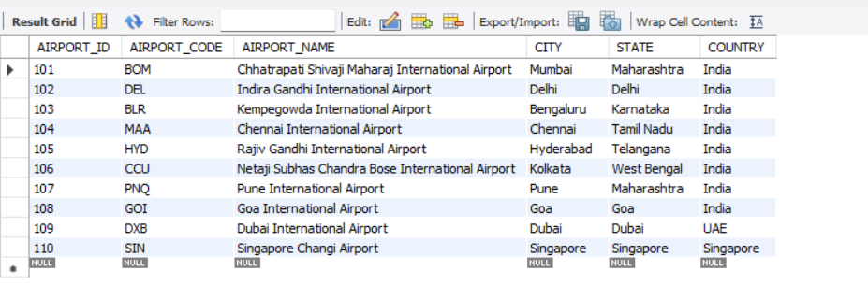
SELECT * from airport;

- Insert Into Aircraft Table
INSERT INTO aircraft
(AIRCRAFT_ID, AIRLINE_ID, MODEL, TOTAL_SEATS, MANUFACTURING_YEAR)
VALUES
(201, 1, 'Airbus A320', 180, 2019),
(202, 1, 'Boeing 787', 256, 2020),
(203, 2, 'Airbus A320neo', 186, 2021),
(204, 2, 'Airbus A321neo', 222, 2022),
(205, 3, 'Airbus A321', 188, 2018),
(206, 4, 'Boeing 777-300ER', 354, 2019),
(207, 4, 'Airbus A380', 484, 2020),
(208, 5, 'Airbus A350', 253, 2021),
(209, 5, 'Boeing 787-10', 337, 2022),
(210, 3, 'Boeing 737', 160, 2017);

SELECT * from aircraft;
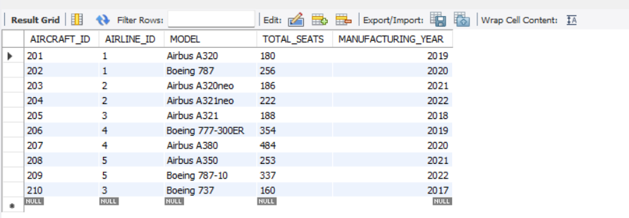
- Insert Into Flight Table
INSERT INTO flight
(FLIGHT_ID, FLIGHT_NO, AIRLINE_ID, AIRCRAFT_ID,
SOURCE_AIRPORT_ID, DESTINATION_AIRPORT_ID,
DEPARTURE_TIME, ARRIVAL_TIME, BASE_FARE, STATUS)
VALUES
(301, 'AI101', 1, 201, 101, 102,
'2026-09-01 06:30:00', '2026-09-01 08:45:00', 5500.00, 'Scheduled'),

(302, 'AI102', 1, 202, 102, 101,
'2026-09-02 10:00:00', '2026-09-02 12:20:00', 6200.00, 'Scheduled'),

(303, '6E201', 2, 203, 101, 103,
'2026-09-03 07:15:00', '2026-09-03 09:05:00', 4800.00, 'Scheduled'),

(304, '6E202', 2, 204, 103, 101,
'2026-09-04 18:00:00', '2026-09-04 20:00:00', 5100.00, 'Scheduled'),

(305, 'UK301', 3, 205, 101, 104,
'2026-09-05 09:30:00', '2026-09-05 11:40:00', 6700.00, 'Scheduled'),

(306, 'UK302', 3, 210, 104, 101,
'2026-09-06 15:00:00', '2026-09-06 17:15:00', 6900.00, 'Scheduled'),

(307, 'AI205', 1, 201, 101, 105,
'2026-09-07 11:00:00', '2026-09-07 12:50:00', 4300.00, 'Scheduled'),

(308, '6E305', 2, 203, 102, 106,
'2026-09-08 13:00:00', '2026-09-08 15:20:00', 5900.00, 'Scheduled'),

(309, 'EK501', 4, 206, 101, 109,
'2026-09-09 04:00:00', '2026-09-09 06:15:00', 18500.00, 'Scheduled'),

(310, 'EK502', 4, 207, 109, 101,
'2026-09-10 14:00:00', '2026-09-10 19:00:00', 20500.00, 'Scheduled'),

(311, 'SQ421', 5, 208, 101, 110,
'2026-09-11 22:00:00', '2026-09-12 06:00:00', 22000.00, 'Scheduled'),

(312, 'SQ422', 5, 209, 110, 101,
'2026-09-13 09:00:00', '2026-09-13 17:00:00', 22500.00, 'Scheduled'),

(313, 'AI410', 1, 202, 101, 107,
'2026-09-14 08:00:00', '2026-09-14 09:10:00', 3200.00, 'Scheduled'),

(314, '6E411', 2, 204, 107, 101,
'2026-09-15 19:00:00', '2026-09-15 20:10:00', 3500.00, 'Scheduled'),

(315, 'AI510', 1, 201, 101, 108,
'2026-09-16 16:00:00', '2026-09-16 17:15:00', 4200.00, 'Scheduled');

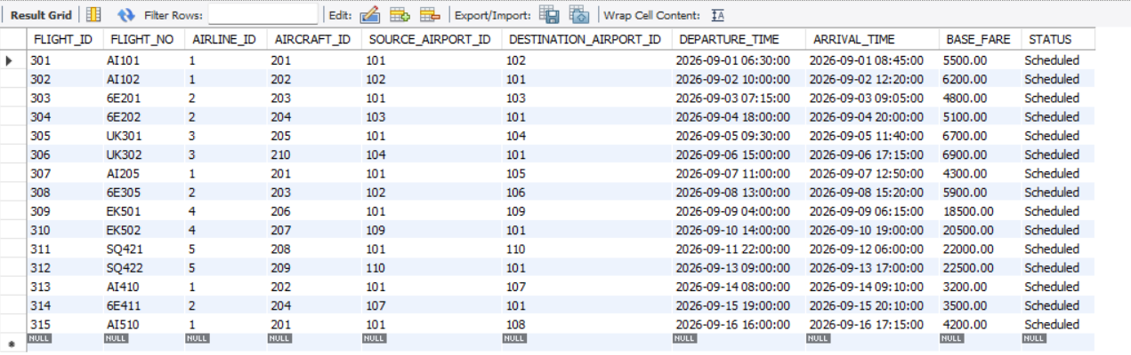
SELECT * from flight;

- Insert Into Passenger Table
INSERT INTO passenger
(PASSENGER_ID, FIRST_NAME, LAST_NAME, GENDER, AGE, PHONE_NO, EMAIL, CITY, PASSPORT_NO)
VALUES
(1, 'Rahul', 'Sharma', 'Male', 28, 9876500001, 'rahul.sharma@gmail.com', 'Mumbai', 'P100001'),
(2, 'Priya', 'Patel', 'Female', 31, 9876500002, 'priya.patel@gmail.com', 'Pune', 'P100002'),
(3, 'Amit', 'Verma', 'Male', 35, 9876500003, 'amit.verma@gmail.com', 'Delhi', 'P100003'),
(4, 'Sneha', 'Desai', 'Female', 26, 9876500004, 'sneha.desai@gmail.com', 'Mumbai', 'P100004'),
(5, 'Rohan', 'Mehta', 'Male', 42, 9876500005, 'rohan.mehta@gmail.com', 'Ahmedabad', 'P100005'),
(6, 'Anjali', 'Kumar', 'Female', 29, 9876500006, 'anjali.kumar@gmail.com', 'Delhi', 'P100006'),
(7, 'Vikram', 'Singh', 'Male', 38, 9876500007, 'vikram.singh@gmail.com', 'Jaipur', 'P100007'),
(8, 'Neha', 'Joshi', 'Female', 24, 9876500008, 'neha.joshi@gmail.com', 'Pune', 'P100008'),
(9, 'Arjun', 'Nair', 'Male', 33, 9876500009, 'arjun.nair@gmail.com', 'Kochi', 'P100009'),
(10, 'Kavita', 'Shah', 'Female', 40, 9876500010, 'kavita.shah@gmail.com', 'Mumbai', 'P100010'),

(11, 'Sanjay', 'Rao', 'Male', 45, 9876500011, 'sanjay.rao@gmail.com', 'Bengaluru', 'P100011'),
(12, 'Pooja', 'Iyer', 'Female', 27, 9876500012, 'pooja.iyer@gmail.com', 'Chennai', 'P100012'),
(13, 'Karan', 'Malhotra', 'Male', 30, 9876500013, 'karan.malhotra@gmail.com', 'Delhi', 'P100013'),
(14, 'Riya', 'Kapoor', 'Female', 22, 9876500014, 'riya.kapoor@gmail.com', 'Mumbai', 'P100014'),
(15, 'Nikhil', 'Gupta', 'Male', 36, 9876500015, 'nikhil.gupta@gmail.com', 'Pune', 'P100015'),
(16, 'Meera', 'Chopra', 'Female', 34, 9876500016, 'meera.chopra@gmail.com', 'Kolkata', 'P100016'),
(17, 'Aditya', 'Kulkarni', 'Male', 25, 9876500017, 'aditya.kulkarni@gmail.com', 'Pune', 'P100017'),
(18, 'Simran', 'Kaur', 'Female', 29, 9876500018, 'simran.kaur@gmail.com', 'Amritsar', 'P100018'),
(19, 'Manish', 'Yadav', 'Male', 41, 9876500019, 'manish.yadav@gmail.com', 'Lucknow', 'P100019'),
(20, 'Ayesha', 'Khan', 'Female', 32, 9876500020, 'ayesha.khan@gmail.com', 'Mumbai', 'P100020'),

(21, 'Varun', 'Bose', 'Male', 37, 9876500021, 'varun.bose@gmail.com', 'Kolkata', 'P100021'),
(22, 'Tanya', 'Sen', 'Female', 26, 9876500022, 'tanya.sen@gmail.com', 'Kolkata', 'P100022'),
(23, 'Deepak', 'Mishra', 'Male', 48, 9876500023, 'deepak.mishra@gmail.com', 'Varanasi', 'P100023'),
(24, 'Isha', 'Reddy', 'Female', 23, 9876500024, 'isha.reddy@gmail.com', 'Hyderabad', 'P100024'),
(25, 'Mohit', 'Agarwal', 'Male', 39, 9876500025, 'mohit.agarwal@gmail.com', 'Jaipur', 'P100025'),
(26, 'Divya', 'Menon', 'Female', 30, 9876500026, 'divya.menon@gmail.com', 'Kochi', 'P100026'),
(27, 'Suresh', 'Pillai', 'Male', 52, 9876500027, 'suresh.pillai@gmail.com', 'Kochi', 'P100027'),
(28, 'Nandini', 'Rao', 'Female', 28, 9876500028, 'nandini.rao@gmail.com', 'Bengaluru', 'P100028'),
(29, 'Akash', 'Patil', 'Male', 27, 9876500029, 'akash.patil@gmail.com', 'Mumbai', 'P100029'),
(30, 'Shreya', 'Das', 'Female', 33, 9876500030, 'shreya.das@gmail.com', 'Kolkata', 'P100030'),

(31, 'Harsh', 'Thakur', 'Male', 31, 9876500031, 'harsh.thakur@gmail.com', 'Delhi', 'P100031'),
(32, 'Mansi', 'Joshi', 'Female', 25, 9876500032, 'mansi.joshi@gmail.com', 'Pune', 'P100032'),
(33, 'Raj', 'Chavan', 'Male', 44, 9876500033, 'raj.chavan@gmail.com', 'Mumbai', 'P100033'),
(34, 'Swati', 'Naik', 'Female', 36, 9876500034, 'swati.naik@gmail.com', 'Goa', 'P100034'),
(35, 'Yash', 'Saxena', 'Male', 29, 9876500035, 'yash.saxena@gmail.com', 'Delhi', 'P100035'),
(36, 'Komal', 'Bhat', 'Female', 27, 9876500036, 'komal.bhat@gmail.com', 'Bengaluru', 'P100036'),
(37, 'Abhishek', 'Jain', 'Male', 40, 9876500037, 'abhishek.jain@gmail.com', 'Indore', 'P100037'),
(38, 'Aarti', 'Sinha', 'Female', 32, 9876500038, 'aarti.sinha@gmail.com', 'Patna', 'P100038'),
(39, 'Ritesh', 'Tiwari', 'Male', 34, 9876500039, 'ritesh.tiwari@gmail.com', 'Lucknow', 'P100039'),
(40, 'Tanvi', 'Deshmukh', 'Female', 21, 9876500040, 'tanvi.deshmukh@gmail.com', 'Nagpur', 'P100040');

SELECT * from passenger;
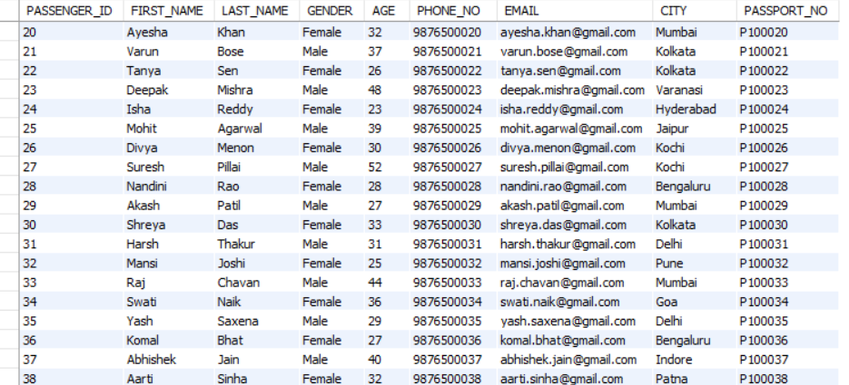
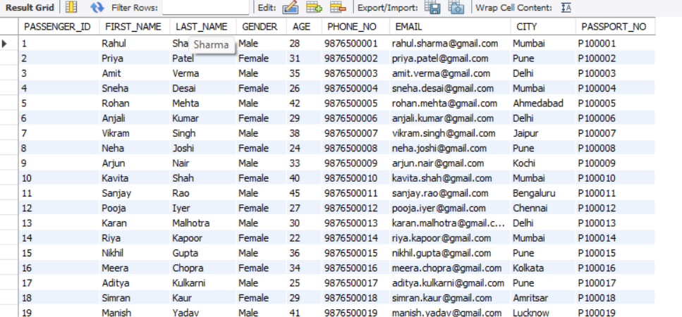

- Insert Into Booking Table
INSERT INTO booking
(BOOKING_ID, PASSENGER_ID, FLIGHT_ID, BOOKING_DATE, CLASS, BOOKING_STATUS, TOTAL_AMOUNT)
VALUES
(5001, 1, 301, '2026-08-01', 'Economy', 'Confirmed', 5500.00),
(5002, 2, 301, '2026-08-02', 'Business', 'Confirmed', 9500.00),
(5003, 3, 302, '2026-08-03', 'Economy', 'Confirmed', 6200.00),
(5004, 4, 303, '2026-08-04', 'Economy', 'Confirmed', 4800.00),
(5005, 5, 304, '2026-08-04', 'Business', 'Confirmed', 8500.00),
(5006, 6, 305, '2026-08-05', 'Economy', 'Confirmed', 6700.00),
(5007, 7, 306, '2026-08-05', 'Economy', 'Cancelled', 0.00),
(5008, 8, 307, '2026-08-05', 'Economy', 'Confirmed', 4300.00),
(5009, 9, 308, '2026-08-05', 'Business', 'Confirmed', 9000.00),
(5010, 10, 309, '2026-08-06', 'Economy', 'Confirmed', 18500.00),

(5011, 11, 310, '2026-08-06', 'Business', 'Confirmed', 32000.00),
(5012, 12, 311, '2026-08-06', 'Economy', 'Confirmed', 22000.00),
(5013, 13, 312, '2026-08-07', 'Economy', 'Confirmed', 22500.00),
(5014, 14, 313, '2026-08-07', 'Economy', 'Confirmed', 3200.00),
(5015, 15, 314, '2026-08-07', 'Business', 'Confirmed', 6500.00),
(5016, 16, 315, '2026-08-08', 'Economy', 'Confirmed', 4200.00),
(5017, 17, 301, '2026-08-08', 'Economy', 'Confirmed', 5500.00),
(5018, 18, 302, '2026-08-08', 'Economy', 'Confirmed', 6200.00),
(5019, 19, 303, '2026-08-09', 'Business', 'Confirmed', 8000.00),
(5020, 20, 304, '2026-08-09', 'Economy', 'Confirmed', 5100.00),

(5021, 21, 305, '2026-08-09', 'Economy', 'Confirmed', 6700.00),
(5022, 22, 306, '2026-08-10', 'Business', 'Confirmed', 10500.00),
(5023, 23, 307, '2026-08-10', 'Economy', 'Confirmed', 4300.00),
(5024, 24, 308, '2026-08-10', 'Economy', 'Confirmed', 5900.00),
(5025, 25, 309, '2026-08-11', 'Business', 'Confirmed', 28000.00),
(5026, 26, 310, '2026-08-11', 'Economy', 'Confirmed', 20500.00),
(5027, 27, 311, '2026-08-11', 'Business', 'Confirmed', 35000.00),
(5028, 28, 312, '2026-08-12', 'Economy', 'Confirmed', 22500.00),
(5029, 29, 313, '2026-08-12', 'Economy', 'Confirmed', 3200.00),
(5030, 30, 314, '2026-08-12', 'Business', 'Confirmed', 6500.00),

(5031, 31, 315, '2026-08-13', 'Economy', 'Confirmed', 4200.00),
(5032, 32, 301, '2026-08-13', 'Economy', 'Confirmed', 5500.00),
(5033, 33, 302, '2026-08-13', 'Business', 'Confirmed', 9500.00),
(5034, 34, 303, '2026-08-14', 'Economy', 'Confirmed', 4800.00),
(5035, 35, 304, '2026-08-14', 'Economy', 'Confirmed', 5100.00),
(5036, 36, 305, '2026-08-14', 'Business', 'Confirmed', 11500.00),
(5037, 37, 306, '2026-08-15', 'Economy', 'Confirmed', 6900.00),
(5038, 38, 307, '2026-08-15', 'Economy', 'Confirmed', 4300.00),
(5039, 39, 308, '2026-08-15', 'Business', 'Confirmed', 9000.00),
(5040, 40, 309, '2026-08-16', 'Economy', 'Confirmed', 18500.00);
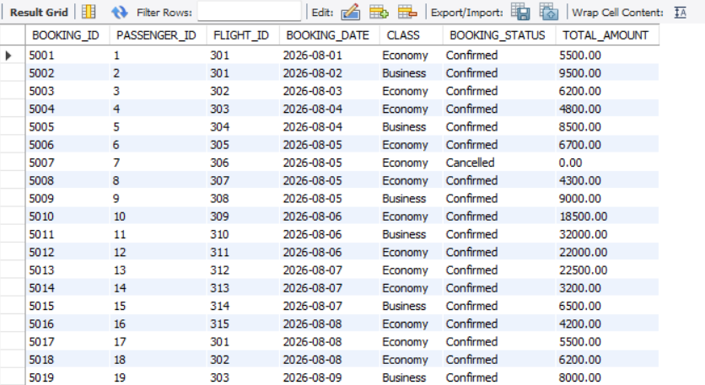
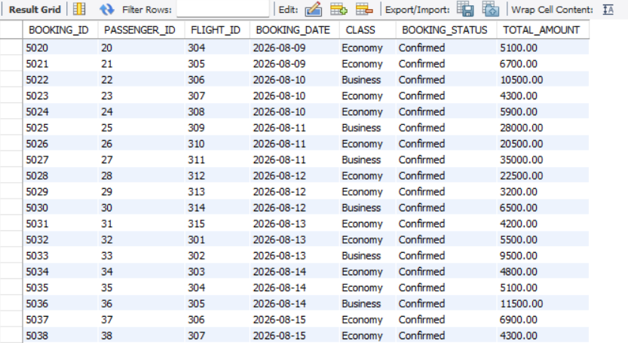
SELECT * from booking;

- Insert Into Seat Table
INSERT INTO seat
(SEAT_ID, BOOKING_ID, SEAT_NO, SEAT_TYPE)
VALUES
(6001,5001,'1A','Window'),
(6002,5002,'1B','Window'),
(6003,5003,'2A','Window'),
(6004,5004,'2B','Middle'),
(6005,5005,'3A','Window'),
(6006,5006,'3B','Middle'),
(6007,5007,'4A','Window'),
(6008,5008,'4B','Middle'),
(6009,5009,'5A','Window'),
(6010,5010,'5B','Middle'),
(6011,5011,'6A','Window'),
(6012,5012,'6B','Middle'),
(6013,5013,'7A','Window'),
(6014,5014,'7B','Middle'),
(6015,5015,'8A','Window'),
(6016,5016,'8B','Middle'),
(6017,5017,'9A','Window'),
(6018,5018,'9B','Middle'),
(6019,5019,'10A','Window'),
(6020,5020,'10B','Middle'),
(6021,5021,'11A','Window'),
(6022,5022,'11B','Middle'),
(6023,5023,'12A','Window'),
(6024,5024,'12B','Middle'),
(6025,5025,'13A','Window'),
(6026,5026,'13B','Middle'),
(6027,5027,'14A','Window'),
(6028,5028,'14B','Middle'),
(6029,5029,'15A','Window'),
(6030,5030,'15B','Middle'),
(6031,5031,'16A','Window'),
(6032,5032,'16B','Middle'),
(6033,5033,'17A','Window'),
(6034,5034,'17B','Middle'),
(6035,5035,'18A','Window'),
(6036,5036,'18B','Middle'),
(6037,5037,'19A','Window'),
(6038,5038,'19B','Middle'),
(6039,5039,'20A','Window'),
(6040,5040,'20B','Middle');

SELECT * from seat;
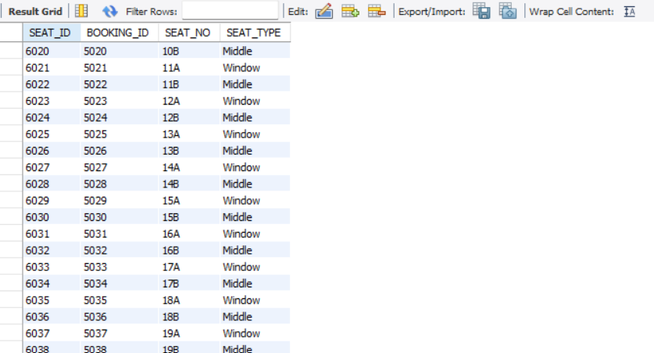
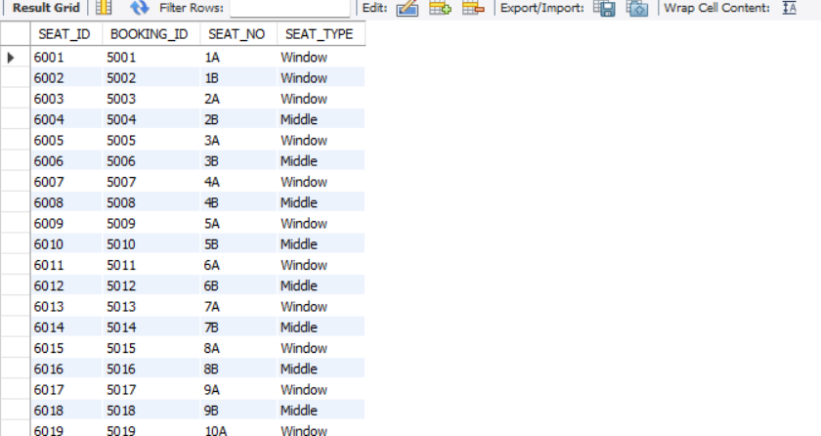
- Insert Into Payment Table
INSERT INTO payment
(PAYMENT_ID, BOOKING_ID, PAYMENT_DATE, PAYMENT_METHOD, PAYMENT_STATUS, AMOUNT)
VALUES
(7001,5001,'2026-08-01','UPI','Paid',5500.00),
(7002,5002,'2026-08-02','Card','Paid',9500.00),
(7003,5003,'2026-08-03','UPI','Paid',6200.00),
(7004,5004,'2026-08-04','Card','Paid',4800.00),
(7005,5005,'2026-08-04','Net Banking','Paid',8500.00),
(7006,5006,'2026-08-05','UPI','Paid',6700.00),
(7007,5007,'2026-08-05','Card','Refunded',0.00),
(7008,5008,'2026-08-05','UPI','Paid',4300.00),
(7009,5009,'2026-08-05','Card','Paid',9000.00),
(7010,5010,'2026-08-06','UPI','Paid',18500.00),
(7011,5011,'2026-08-06','Card','Paid',32000.00),
(7012,5012,'2026-08-06','UPI','Paid',22000.00),
(7013,5013,'2026-08-07','Card','Paid',22500.00),
(7014,5014,'2026-08-07','UPI','Paid',3200.00),
(7015,5015,'2026-08-07','Card','Paid',6500.00),
(7016,5016,'2026-08-08','UPI','Paid',4200.00),
(7017,5017,'2026-08-08','Card','Paid',5500.00),
(7018,5018,'2026-08-08','UPI','Paid',6200.00),
(7019,5019,'2026-08-09','Card','Paid',8000.00),
(7020,5020,'2026-08-09','UPI','Paid',5100.00),
(7021,5021,'2026-08-09','Card','Paid',6700.00),
(7022,5022,'2026-08-10','UPI','Paid',10500.00),
(7023,5023,'2026-08-10','Card','Paid',4300.00),
(7024,5024,'2026-08-10','UPI','Paid',5900.00),
(7025,5025,'2026-08-11','Card','Paid',28000.00),
(7026,5026,'2026-08-11','UPI','Paid',20500.00),
(7027,5027,'2026-08-11','Card','Paid',35000.00),
(7028,5028,'2026-08-12','UPI','Paid',22500.00),
(7029,5029,'2026-08-12','Card','Paid',3200.00),
(7030,5030,'2026-08-12','UPI','Paid',6500.00),
(7031,5031,'2026-08-13','Card','Paid',4200.00),
(7032,5032,'2026-08-13','UPI','Paid',5500.00),
(7033,5033,'2026-08-13','Card','Paid',9500.00),
(7034,5034,'2026-08-14','UPI','Paid',4800.00),
(7035,5035,'2026-08-14','Card','Paid',5100.00),
(7036,5036,'2026-08-14','UPI','Paid',11500.00),
(7037,5037,'2026-08-15','Card','Paid',6900.00),
(7038,5038,'2026-08-15','UPI','Paid',4300.00),
(7039,5039,'2026-08-15','Card','Paid',9000.00),
(7040,5040,'2026-08-16','UPI','Paid',18500.00);

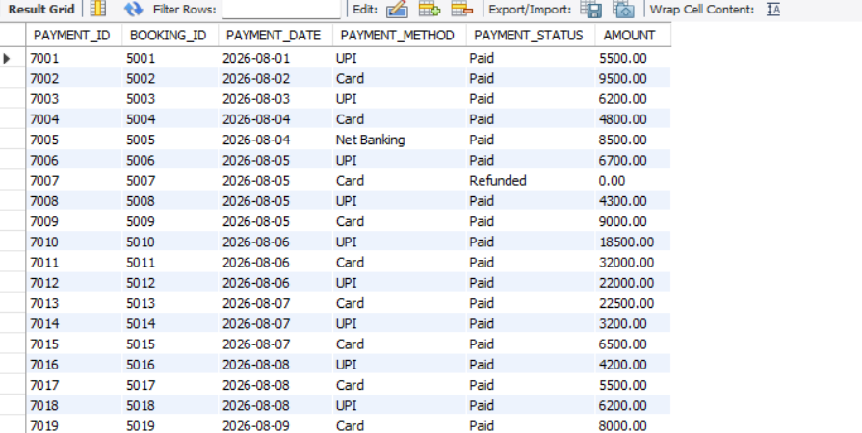
SELECT * from payment;

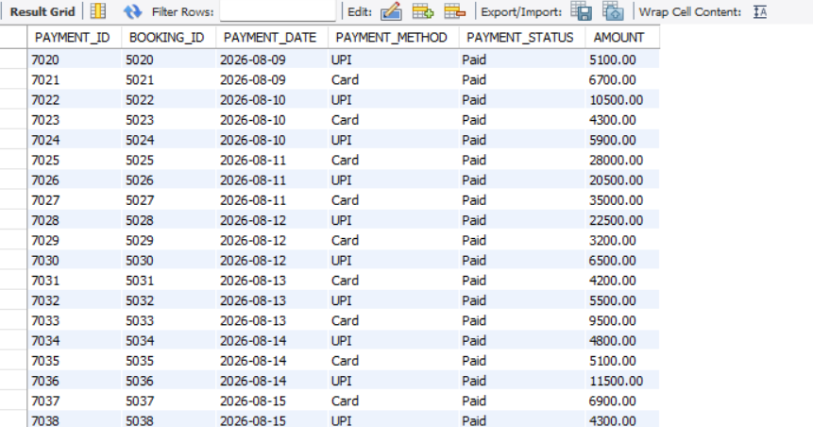

Questions

Q.1 Find the total number of passengers in the passenger table.
COUNT()
SELECT COUNT(*) AS total_passengers
FROM passenger;
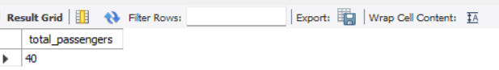

Q.2 Find the total revenue generated from all bookings using TOTAL_AMOUNT.
SUM()
SELECT SUM(TOTAL_AMOUNT) AS total_revenue
FROM booking;
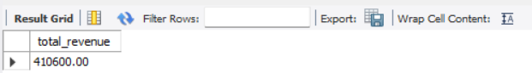

Q.3 Find the average BASE_FARE of all flights.
AVG()
SELECT AVG(BASE_FARE) AS average_fare
FROM flight;
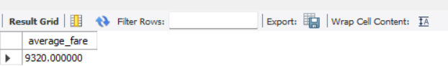

Q.4 Find the highest and lowest flight base fare.
MAX() + MIN()
SELECT
MAX(BASE_FARE) AS highest_fare,
MIN(BASE_FARE) AS lowest_fare
FROM flight;
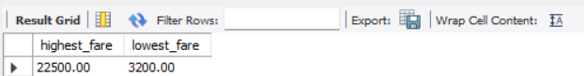

Q.5 Display all passengers whose age is greater than 35.
WHERE
SELECT *
FROM passenger
WHERE AGE > 35;
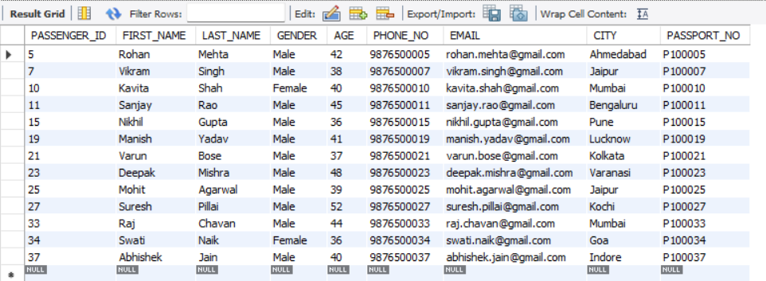

Q.6 Find the number of passengers from each city.
GROUP BY + COUNT
SELECT CITY, COUNT(*) AS passenger_count
FROM passenger
GROUP BY CITY;
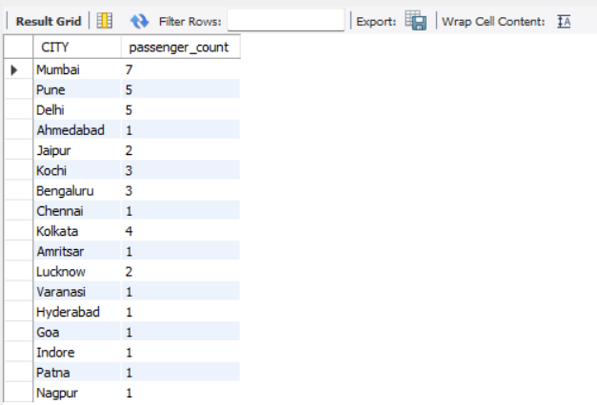

Q.7 Find the total booking amount generated by each class.
GROUP BY + SUM()
SELECT
CLASS,
SUM(TOTAL_AMOUNT) AS total_revenue
FROM booking
GROUP BY CLASS;
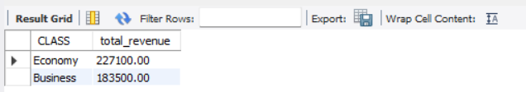

Q.8 Display each flight number along with its airline name.
INNER JOIN
SELECT
f.FLIGHT_NO,
a.AIRLINE_NAME
FROM flight f
INNER JOIN airline a
ON f.AIRLINE_ID = a.AIRLINE_ID;
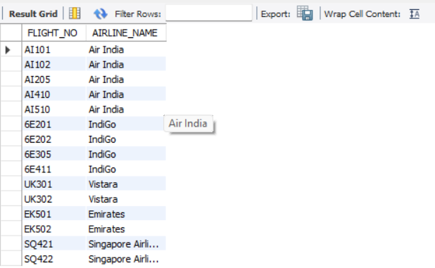

Q.9 Display all passengers and their booking IDs, including passengers
who have not made any booking.
LEFT JOIN
SELECT
p.PASSENGER_ID,
p.FIRST_NAME,
p.LAST_NAME,
b.BOOKING_ID
FROM passenger p
LEFT JOIN booking b
ON p.PASSENGER_ID = b.PASSENGER_ID;
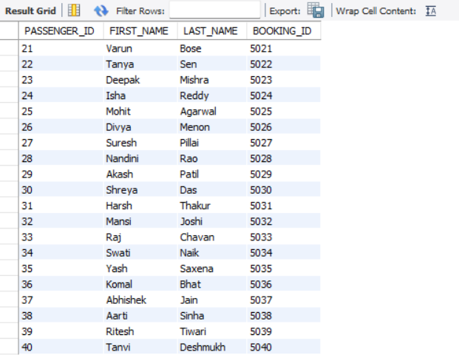

Q.10 Display all bookings along with passenger names using a RIGHT JOIN.
RIGHT JOIN
SELECT
p.FIRST_NAME,
p.LAST_NAME,
b.BOOKING_ID,
b.TOTAL_AMOUNT
FROM passenger p
RIGHT JOIN booking b
ON p.PASSENGER_ID = b.PASSENGER_ID;
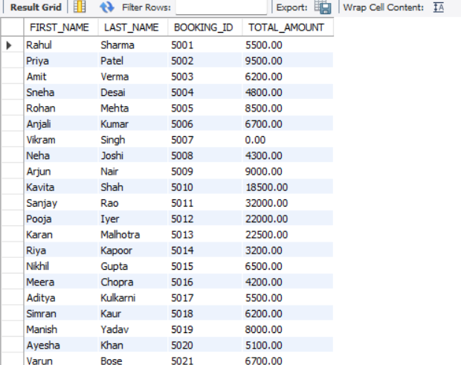
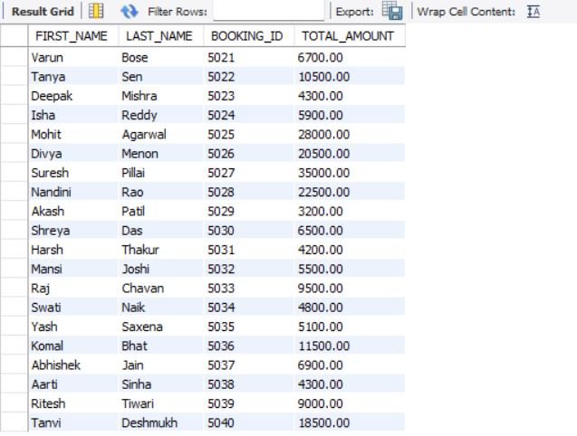

Q.11 Find the total booking revenue generated by each airline.
INNER JOIN + SUM() + GROUP BY
SELECT
a.AIRLINE_NAME,
SUM(b.TOTAL_AMOUNT) AS total_revenue
FROM airline a
INNER JOIN flight f
ON a.AIRLINE_ID = f.AIRLINE_ID
INNER JOIN booking b
ON f.FLIGHT_ID = b.FLIGHT_ID
GROUP BY a.AIRLINE_NAME;
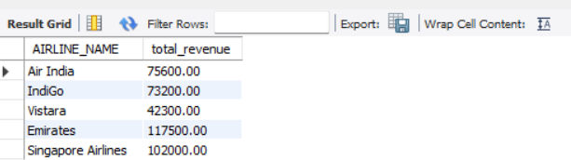

Q.12 Find the number of bookings made for each airline.
INNER JOIN + COUNT() + GROUP BY
SELECT
a.AIRLINE_NAME,
COUNT(b.BOOKING_ID) AS booking_count
FROM airline a
INNER JOIN flight f
ON a.AIRLINE_ID = f.AIRLINE_ID
INNER JOIN booking b
ON f.FLIGHT_ID = b.FLIGHT_ID
GROUP BY a.AIRLINE_NAME;
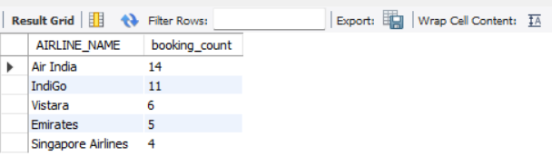

Q.13 Find airlines having more than 5 bookings.
GROUP BY + HAVING
SELECT
a.AIRLINE_NAME,
COUNT(b.BOOKING_ID) AS booking_count
FROM airline a
INNER JOIN flight f
ON a.AIRLINE_ID = f.AIRLINE_ID
INNER JOIN booking b
ON f.FLIGHT_ID = b.FLIGHT_ID
GROUP BY a.AIRLINE_NAME
HAVING COUNT(b.BOOKING_ID) > 5;

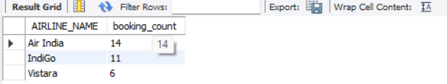

Q.14 Display the flight number, airline name, and base fare for flights whose base
fare is greater than ₹10,000.
JOIN + WHERE

SELECT
f.FLIGHT_NO,
a.AIRLINE_NAME,
f.BASE_FARE
FROM flight f
INNER JOIN airline a
ON f.AIRLINE_ID = a.AIRLINE_ID
WHERE f.BASE_FARE > 10000;
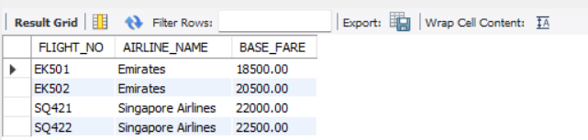

Q.15 Find all female passengers whose age is greater than 30.
WHERE + AND
SELECT *
FROM passenger
WHERE GENDER = 'Female'
AND AGE > 30;
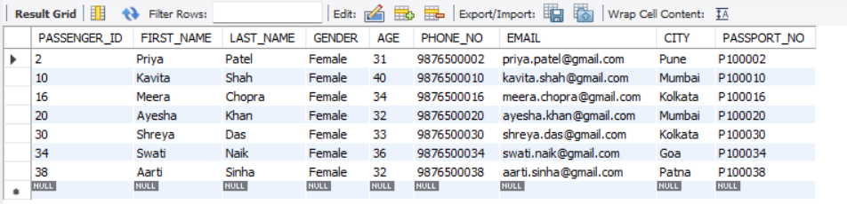

Q.16 Find bookings whose TOTAL_AMOUNT is greater than the average booking
amount.
Subquery + AVG()
SELECT *
FROM booking
WHERE TOTAL_AMOUNT > (
SELECT AVG(TOTAL_AMOUNT)
FROM booking
);
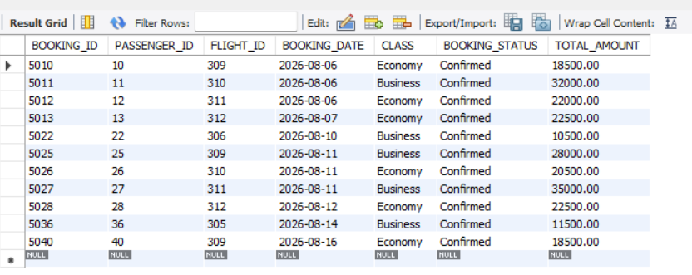

Q.17 Display booking ID and categorize the booking amount as Low, Medium, or
High.
CASE
SELECT
BOOKING_ID,
TOTAL_AMOUNT,
CASE
WHEN TOTAL_AMOUNT < 10000 THEN 'Low'
WHEN TOTAL_AMOUNT BETWEEN 10000 AND 20000 THEN 'Medium'
ELSE 'High'
END AS amount_category
FROM booking;
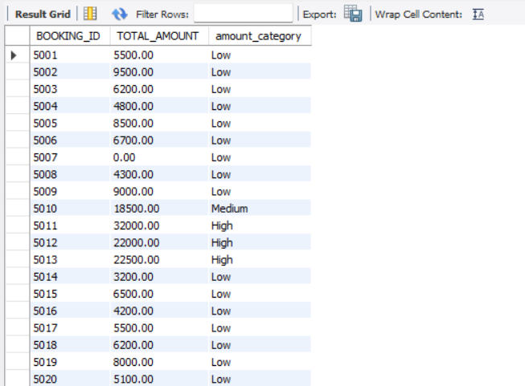

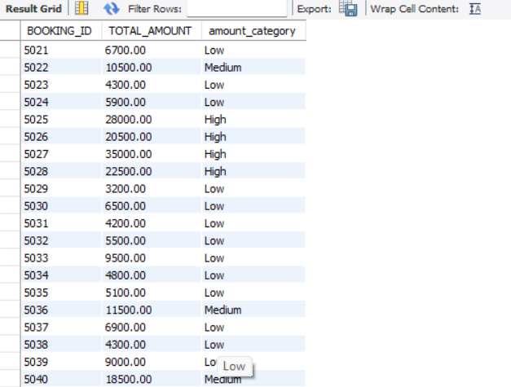

Q.18 Using a CTE, calculate the total revenue generated by each airline.
CTE + SUM()
WITH airline_revenue AS (
SELECT
a.AIRLINE_NAME,
SUM(b.TOTAL_AMOUNT) AS total_revenue
FROM airline a
INNER JOIN flight f
ON a.AIRLINE_ID = f.AIRLINE_ID
INNER JOIN booking b
ON f.FLIGHT_ID = b.FLIGHT_ID
GROUP BY a.AIRLINE_NAME
)
SELECT *
FROM airline_revenue;
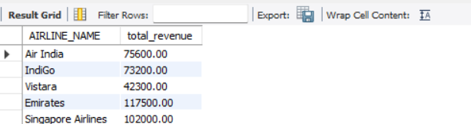

Q.19 Rank passengers according to their total booking expenditure.
RANK() + Window Function
SELECT
p.PASSENGER_ID,
p.FIRST_NAME,
p.LAST_NAME,
SUM(b.TOTAL_AMOUNT) AS total_spent,
RANK() OVER (
ORDER BY SUM(b.TOTAL_AMOUNT) DESC
) AS spending_rank
FROM passenger p
INNER JOIN booking b
ON p.PASSENGER_ID = b.PASSENGER_ID
GROUP BY
p.PASSENGER_ID,
p.FIRST_NAME,
p.LAST_NAME;
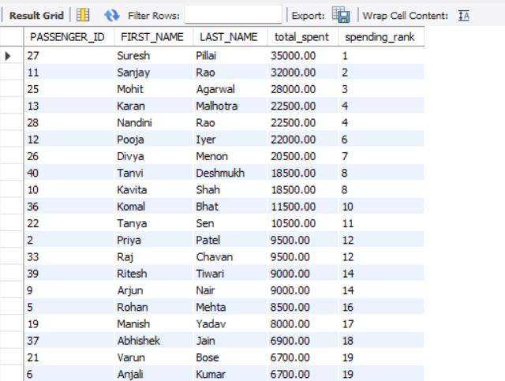

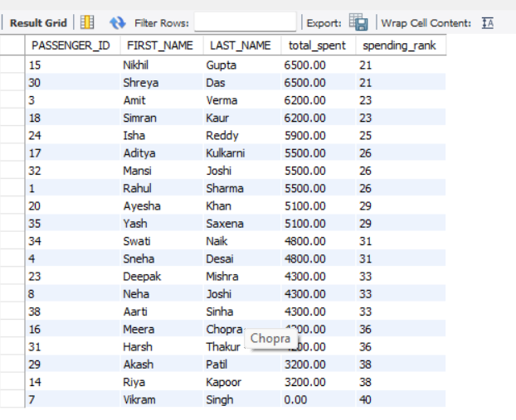

CONCLUSION
The Airline Reservation System project successfully demonstrates how SQL can be used to design and manage a relational database for airline operations. The database contains interconnected tables such as Airline, Airport, Aircraft, Flight, Passenger, Booking, Seat, and Payment, with primary and foreign keys used to maintain relationships and data integrity.
Through this project, various SQL concepts were implemented, including data retrieval using SELECT and WHERE, sorting, INNER JOINs, aggregate functions, GROUP BY, HAVING, subqueries, CASE statements, CTEs, and window functions. These operations make it possible to analyze passenger information, flight details, bookings, revenues, payments, and airline performance.
Overall, the project provides practical experience in database design, SQL querying, data management, and analysis. It shows how a well-structured relational database can organize airline reservation data and help generate meaningful information for managing flights, passengers, bookings, seats, and payments.

